Computer Language Coding Concepts

Pointer to Pointer Get & Set
The target object of a related item or related list item does not have to be pointed out by the ID of the object, but can also be pointed out by another related item or related list item. This was already explained in the article Pointer to Pointer.

When the target of a related item or related list item is pointed out by another related item or related list item, the system interface of a related item or related list item stores the ID of the other related item or related list item:

Other Related Item . ID
Other Related List Item . ID

The system interface also holds commands, you can call to assign or retrieve the target related item or related list item:

Other Related Item . Get
Other Related Item . Set
Other Related List Item . Get
Other Related List Item . Set

By default these members just return and set the pointer target. But calls to these members can be extended with procedures around the assignment and retrieval, as explained in the section Extending the System Interface.

Perhaps in the future a more practical approach will be found, to make assigning an object reference or a pointer to a pointer more alike. But perhaps it is not so bad to clearly see the difference between these different kinds of object targeting.

Other Related Item . ID and Other Related List Item . ID are storage variables of the mentioned Get and Set procedures. Other Related Item . ID and Other Related List Item . ID are only accessible to the corresponding Get and Set commands and their extension procedures. How such access control is accomplished will be covered by the Black Boxing articles.

The mentioned system members are displayed in a diagram as follows:

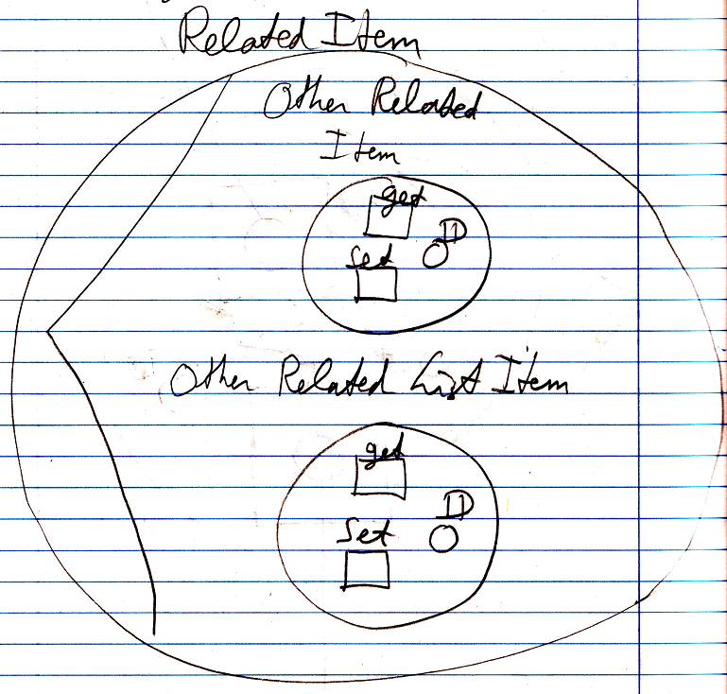

Because the contents of the target object are probably not visible in the diagram, when the system interface is opened, the target of the related item will be connected to the Other Related Item . ID or Other Related List Item . ID of the system interface:

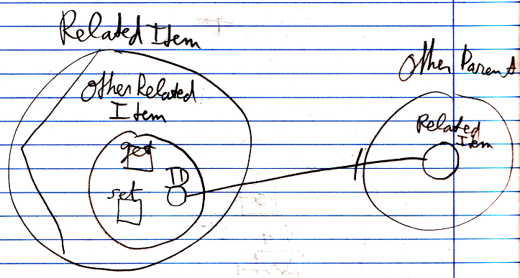

See also: System Objects

Author & Copyright: Jan-Joost van Zon Date: July 18, 2008 – July 23, 2009 Location: Oosterhout, The Netherlands Status: Finished

